Notes following our meeting on March 19th, 2020

Revisions:
- Joseph 2020-03-21: first draft
- Joseph 2020-03-22: added info about NYPL tools

Ideas for Semantic segmentation
Here, “Semantic segmentation” = “Image segmentation” + “pixel classification”.

Original pipeline suggested by Yizi
Image segmentation: Superpixel
Prepare labels
Manually: label every superpixels by hand
Fully automatic: Label superpixels by using legend in the maps
(Joseph note: Looks like content/example-based image retrieval here)
Pixel classification
Supervised: training label pixels
Self-supervised
Semi-supervised: Partially labelled image patches for trainning

Some ideas

About the pipeline: making it interactive
I think we could follow the following generic scenario for processing map images:
- The user loads an image (we suppose it is already merged if needed).
- The image is pre-analyzed to extract features, detect color clusters, etc. for later annotation.
- The user performs annotations which may be of different kinds: painting-like, exact polygon creation or modification, selection of areas and tagging…
- When possible in a timely fashion, the annotation system makes use of user input to automatically annotate more data and display the results produced by automated processing to the user.
- The user also has the option to run a longer process (with training for instance) to make use of the annotations entered.
- Loop to 3 until the global result is good enough.
If the user wants to process a series of image from the same collection, some models should be reused, shared and even globally improved for all the images. Such images could be processed in parallel by different users, and also reprocessed when new knowledge (models) is available.
Every interaction with the user should be stored: nature, duration, time, objects, etc. so we can compare the semi-automated (or “assisted”) annotation strategies we will implement and test. Easy to process log formats (like JSON objects with a timestamp) should be generated generously.

Pre-analysis (step 2) options
In the 3 scenarios I develop hereafter, there are various options for step 2 and I think we could try the following ones.
Pre-analysis (step 2) could consist in computing:
- Image subregions with boundaries:
  - SLIC superpixels
  - Color reduction (quantization using k-means clustering for instance) with optional removal of small components (not that simple with color images)
  - (color?) Tree of shapes with opt. simplification
- Or project pixels values into a new space where distances have a better semantic meaning
  - dense SIFT features
  - VGG activation layer using pre-trained weights (imagenet)
  - or just a gray scale values!
Basically, image subregions is about grouping pixels together and eventually assign them a single vector to describe them using Bag of Visual Words or its variants for instance, and pixel embedding is about finding better values for each pixel. It is only a matter of aggregation level, after all.

Interactive scenario 1: assisted painting
Step 3 (user annotation) could consist in painting superpixels / image regions (when painting over a region, the whole region gets flooded)
Step 4 (automated processing) is therefore about propagating an annotation to all the pixels of the region.
Implementation hints: use SLIC or clustering over values (opt. with spatial constraints) computed for each pixel or group of pixels.

Interactive scenario 2: Boundary optimization
Step 3 (user annotation): select “background” and “foreground” regions / pixels belonging to a given class or object, ex: inside and outside building or road

Step 4 (automated processing): using pre-computed boundaries between regions, try to find the best separation between the two regions (in-class samples and out-of-class samples).

Implementation hints:
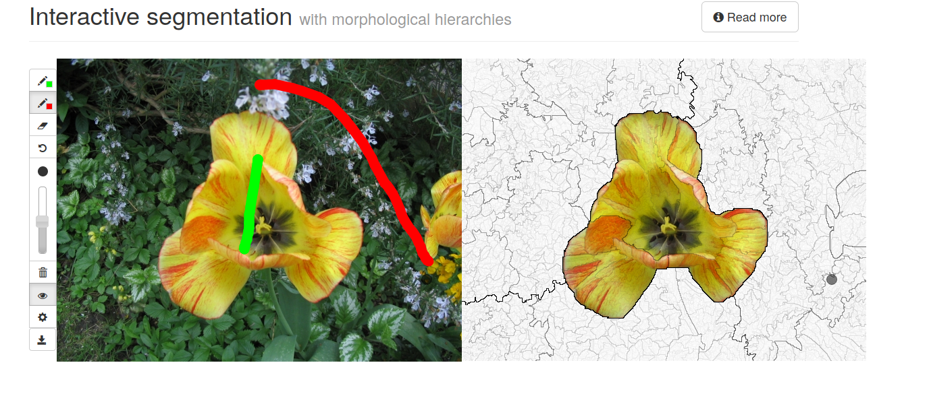
https://perso.esiee.fr/~perretb/ISeg/
We also have some tools available for that at the LRDE, Edwin works on this kind of topic.

Interactive scenario 3: Seed and flow along linear objects
Step 3 (user interaction): for selecting a road for instance, the user clics on the object (seed) and drags toward the expected direction of propagation of the flooding.
Step 4 (automated processing): the “flooding” propagates the selected label among similar regions, jumping over text content while staying withing (possibly interrupted/erased) edges and ridges parallel to the direction of propagation, and stopping at strong perpendicular frontiers.

Illustration tentative
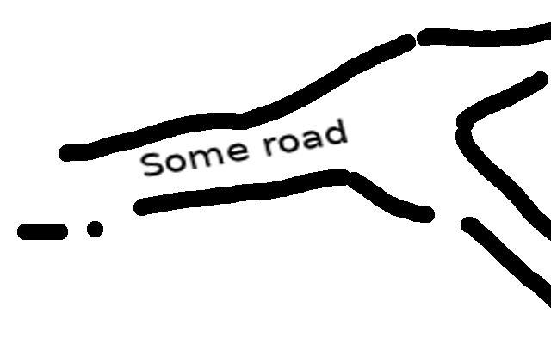 | 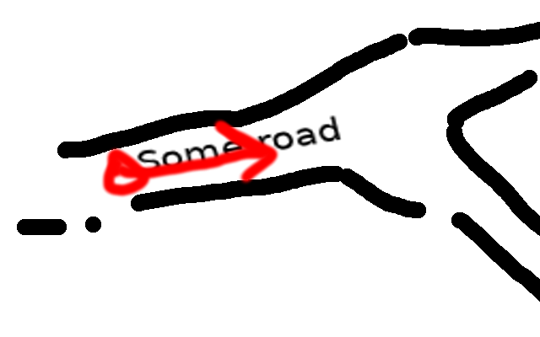 | 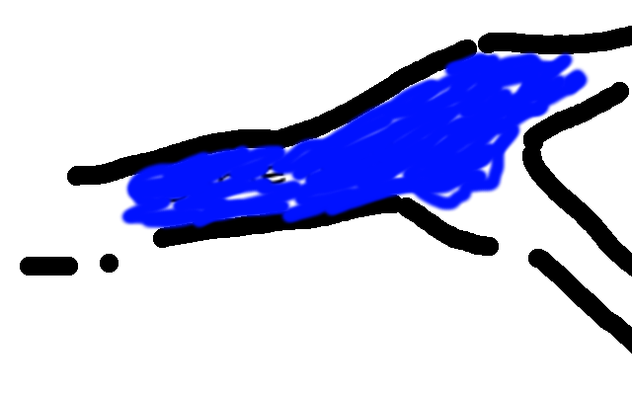
Original image | Clic and drag | Automated flooding

Implementation hint: a kind of modified waterflow algorithm? Detect segments using a good detector (LSD?) and propagate interrupted ridges with a less strong elevation. Use pre-computed regions? Use some form of scale space to extract linear object at a given scale (“zoom level”)?

Interactive scenario 4: incremental classification
Step 3 (user annotation): select samples of each type of region (using map legend or any other region), and eventually of background or other counter-examples.
Step 4 (automated processing):
- either train and apply a multi-class classifier
- or use an approach inspired by content-based image retrieval
  - compute descriptor for each region (fixed or variable size)
  - use examples of a class as queries to rank all other regions by similarity
  - use counter-examples as indicators of class limits
  - relevance feedback can be used to loop and ask the user to correct the results, then improve them (many techniques)

Implementation hints:
- CBIR + relevance feedback
- multi-class classification

Interactive scenario 5: leverage NYPL tools (waterfall annotation)
I'd be super interested in applying the annotation tool for the NYPL to our maps: http://buildinginspector.nypl.org/
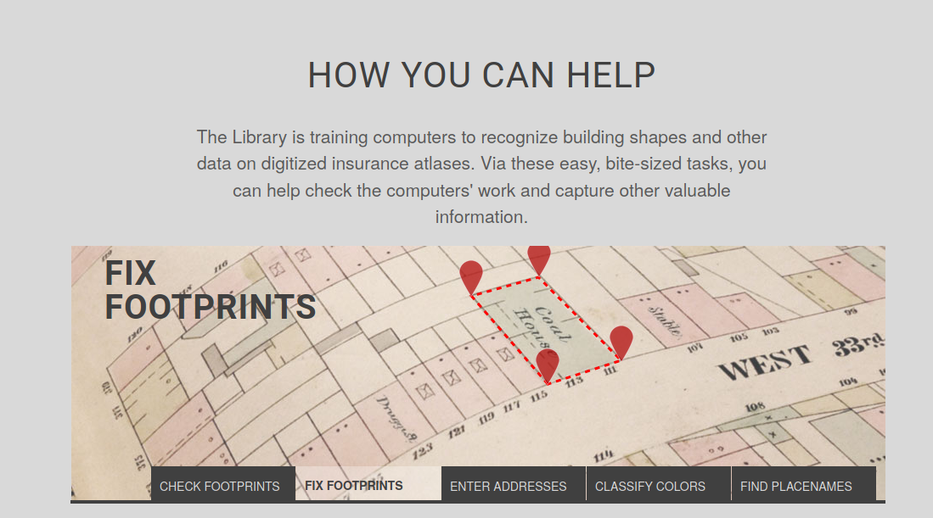
This platform seems to work in a waterfall fashion:
- (auto) detect building polygons
- (manual) validate / invalidate (“to fix”, “ignore”) polygons
- (manual) fix almost OK polygons
- (auto) detect numbers close to those polygons
- (manual) validate / fix / remove numbers and recognize them
- (auto?) identify color of those polygons
- (manual) correct color or detect errors in previous steps
- (auto) detect and read text inside building polygons
- (manual) control and fix text inside those polygons
Only data validated from step i serves as input for step i+1. Validation is manual, and so are corrections.

Step 2 (pre-analysis):
- detect buildings (colored closed shapes for NYPL content) (how?)
- detect numbers (specialized text detector?)
- detect text (within building polygons) (existing text detector?)
- identify colors to classify buildings (color clustering or dimension reduction + classification?)
Step 3 (user annotation):
- validate/mark “to fix”/discard data
- fix data (polygons, object positions, labels for text objects)
Step 4 (automated processing):
- run automated process from cleaned data from previous step

Is there a way to make use of user-provided information to improve the system over time/usage? This would be very interesting.

Implementation hints:
This requires to train detectors for buildings and text, and recognizers for text (numbers and place names). We may have slightly different needs but this is a great work to improve on.
The ability to invalidate data at a later stage of the process requires to track the dependencies between elements. This is very useful to enable complex interaction schemes.

